The Ocarina of Time (The Legend of Zelda)

VGTD, triOs College 2018





The Ocarina of Time will break boundaries and take advantage of the Nintendo 64’s powerful engine to create a fully three dimensional story-driven action/adventure game.

The only intended system for this game is the Nintendo 64. It is the only system that can handle the level of rendering and memory that this project will require. This game is targeted toward the passionate or newbie gamer and will enthrall the audience with the depth of story, gameplay, graphics and music.

The projected development time to create and ship this game is roughly 5 years.

**Gameplay Modes**

The gameplay of this game will involve a 3rd-person camera focusing on the main character. The main character (Link) will be the only playable character in this game. The concept and style will carry on with the hack-and-slash pattern that has become common in past Legend of Zelda games.

As stated above, Ocarina of Time (hereafter referred to as OoT) will be an action/adventure game. The main activities the player can/will/must do are as follows:

* Solving Puzzles
* Fighting Enemies and Surviving against them
* Interacting with NPCs and completing side-quests
* Finding collectibles
* Doing all of the above to complete the main storyline

**Unique Selling Points**

OoT will take advantage of superior graphics and memory to entertain the player by not only telling them an amazing story, but also by having them experience it. No other game will have some of the systems that will be implemented in OoT such as a smooth player-controlled camera, an enriching and exciting storyline with depth and complexity (allowed due to the previously unheard of size of the game), along with completely new and useful items to use against enemies or to solve puzzles.

**Competition**

The biggest current competition is a game released recently in 1997, Final Fantasy 7.

This game was a massive hit in the story/gameplay department, however that not only proves the allure and profitability of having a deeply story-driven game, but also allows The Legend of Zelda to capitalize on the trend. Instead of the gameplay style of Final Fantasy 7’s turn-based combat, OoT will implement real-time action that is guaranteed to tense the player and leave them with a true feeling of accomplishment.

**Challenges for the Player -** Obstacles that players may overcome include:

* The defeat of countless enemies
* Conquering 10-11 dungeons
* Overcoming tricky puzzles
* Defeating Mini-Bosses and Dungeon Boss monsters
* Completing complex side quests that further enrich the story and game world

**Progression**

The player will begin with 3 hearts and no items.

*Hearts*

Hearts determine how much “life force” the player has (how much damage the player can take before they die and must restart at the last entrance they’ve passed through).

As the player progresses through the game, they can find and collect “Heart Pieces” which, in iterations of 4 pieces found, will permanently extend the player’s total life force by 1. Additionally, when the player defeats a dungeon boss, they are awarded with a heart container, which is the equivalent to 4 of those heart pieces.

*Items*

Items range anywhere from a slingshot for ranged combat, bombs for explosive force, or medallions for elemental magic. The player will collect important items in places such as dungeons, which will serve as both a reward and key. There are also some less important items that can be lost, or depleted such as ammunition or currency. Important items will play a key role in the progression as some areas will be inaccessible without the possession and use of an item, perhaps one obtained in the dungeon that was intended to be completed prior to the next in linear succession.

**Victory Condition**

In order to “win” this game, Link needs to overcome 10-11 dungeons, and then defeat the final boss, Ganon, in order to rid the land of Hyrule from that conflict.

**Character**

The player (hereafter referred to as “Link”) will start off having a dream. This dream will reveal Ganon *(the final Boss and topic of conflict which drives the narrative)* chasing Zelda *(the title’s namesake)* out of the protected walls of Hyrule Castle. Link sees Ganon and Ganon is about to attack him when suddenly he is woken up. Link seems to have had a fairy come to him to become his companion. Unlike the other children of the forest, Link never had a fairy companion.

This fairy companion (hereafter referred to as “Navi”(short for navigation)) will be a massive aspect of this game. Navi will help Link throughout the journey in a number of ways:

* Identifying monsters and their weaknesses
* Finding hidden objects
* Contributing to and helping to drive the narrative
* Targeting both Enemies and Objects

Navi’s function will be further outlined in the Gameplay Mechanics section.

Link is in actuality a direct part of the outside world, outside of his sheltered upbringing in the Kokiri Forest. This will explain why a fairy never came to him, as opposed to all of his Kokiri friends. This makes Link feel somewhat ostracized from the community, which helps in his inevitable departure from the safety of the forest.

Once Navi has arrived at Link’s house, she tasks him with seeing the Great Deku Tree.

The Great Deku Tree is a guardian spirit which has been poisoned by Ganon. Ganon left an evil spirit inside the tree’s roots which will eventually kill the tree after much suffering. Link’s first dungeon is to enter and expel this spirit in order to end The Great Deku Tree’s suffering. Link may not leave the confines of Kokiri Forest until the first dungeon is complete (as the entire Kokiri Forest and Great Deku Tree are the tutorial).

After 3 dungeons, Link will have collected a part of the narrative’s macguffins. Once he does, and heads to Hyrule Castle to find the Master Sword (the only weapon that can defeat Ganon), he sleeps for 7 years. There will be a child version of Link and an Adult version of Link.

Concept art for the 3d version for both era of Link and Zelda, and Ganon *(who transforms into a Pig-Like Demon creature)* is on the following page:

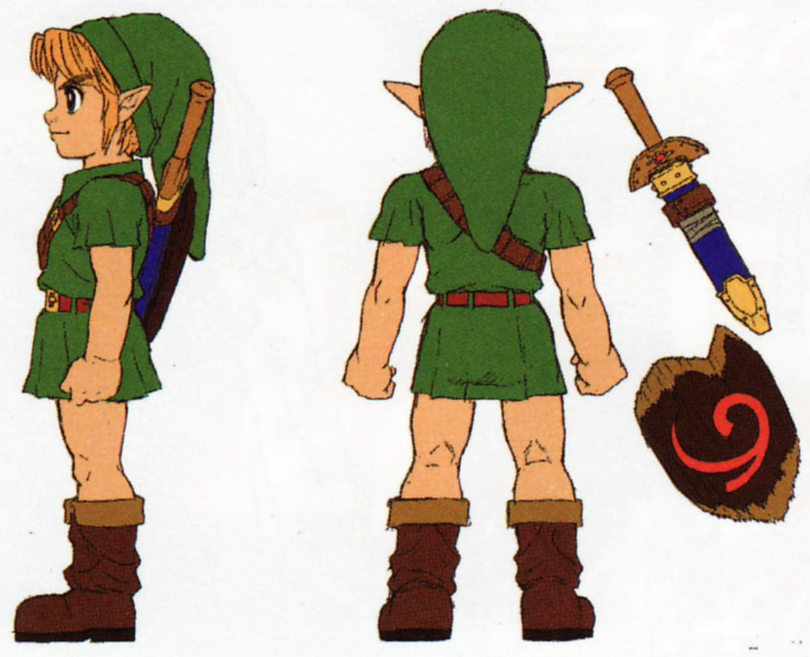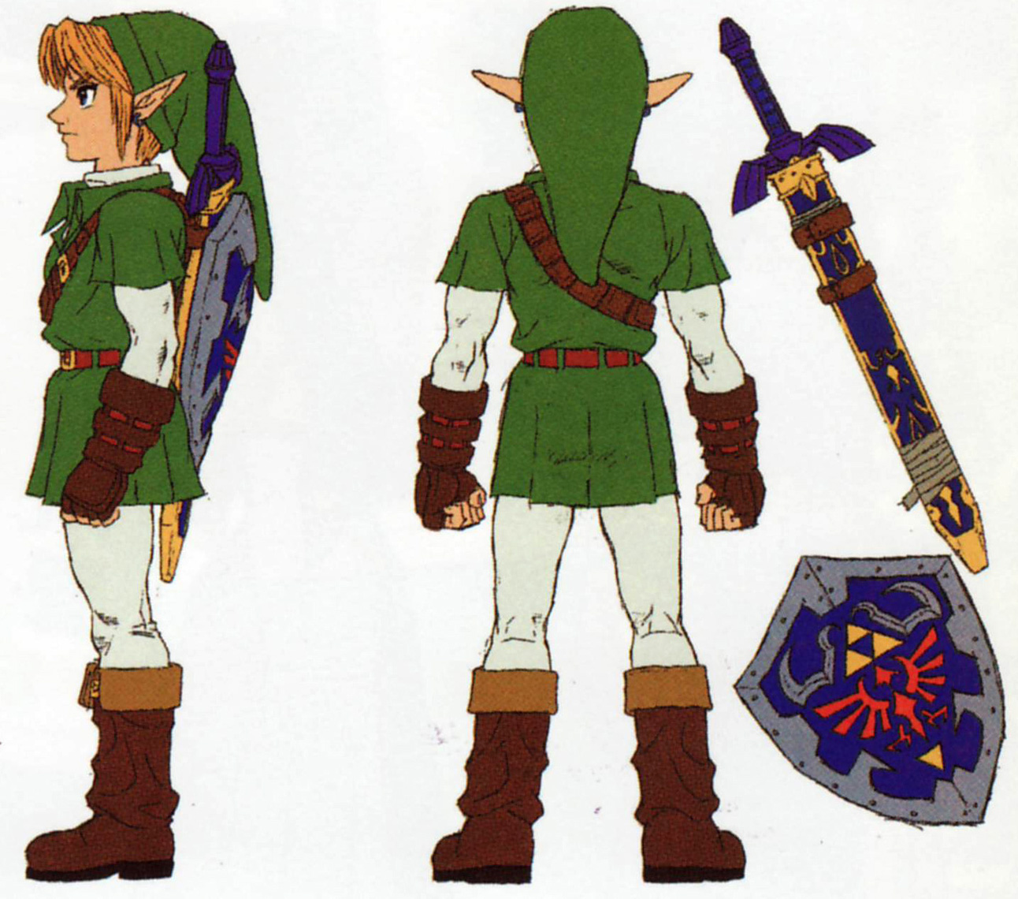

There are numerous other characters, but the concept art is limited to princess Zelda, Ganon and Link as they are the most important characters the story resolves around.

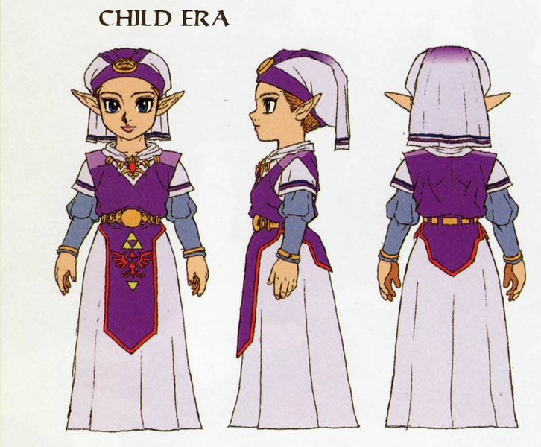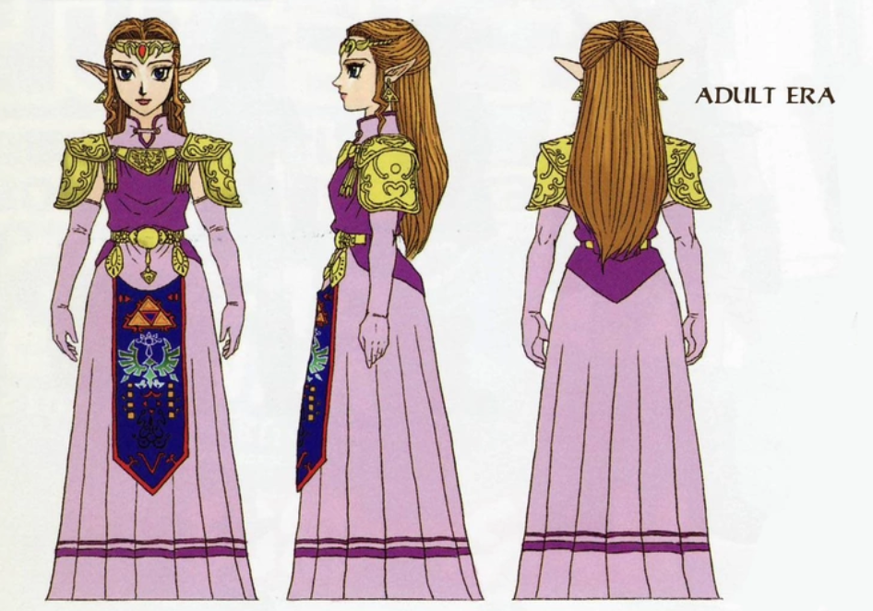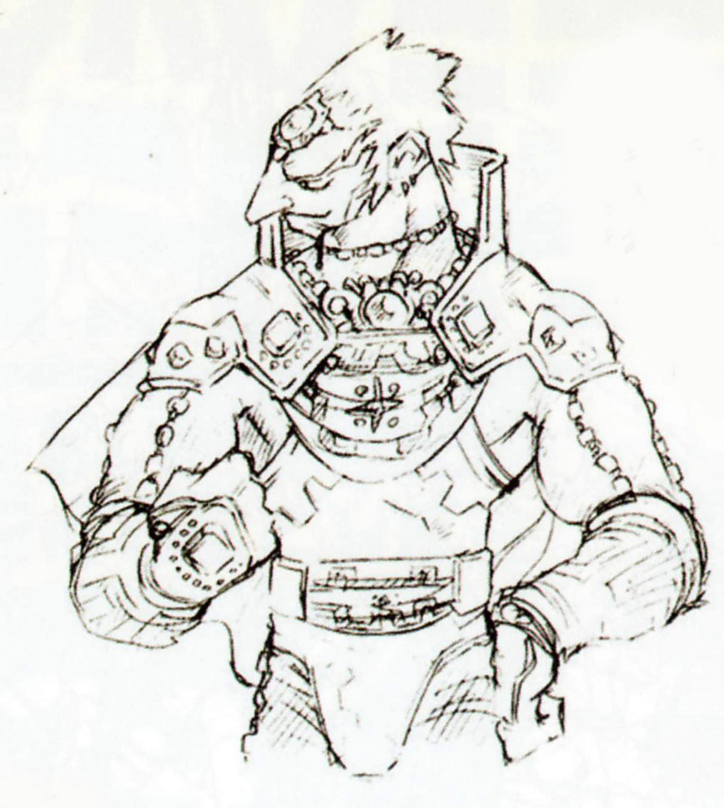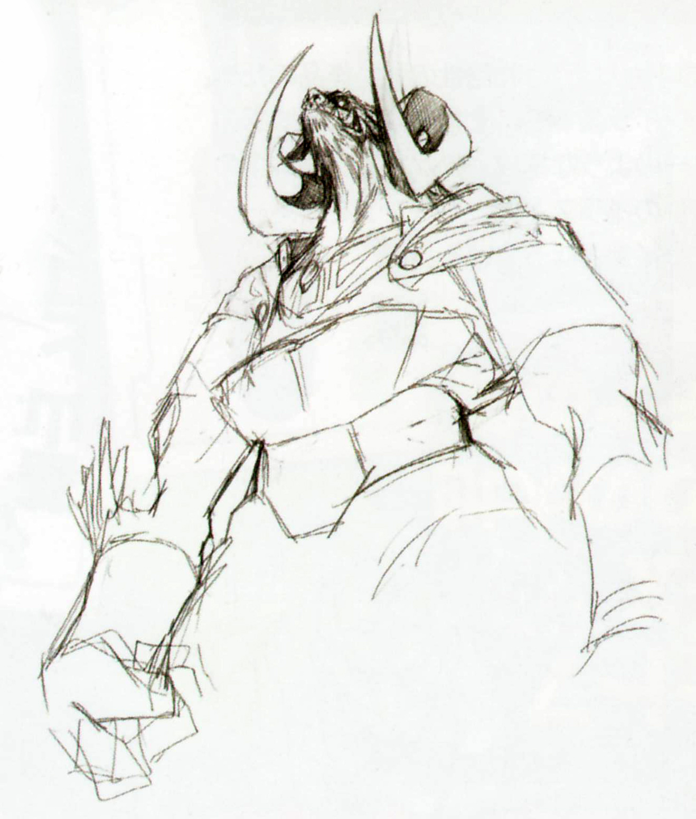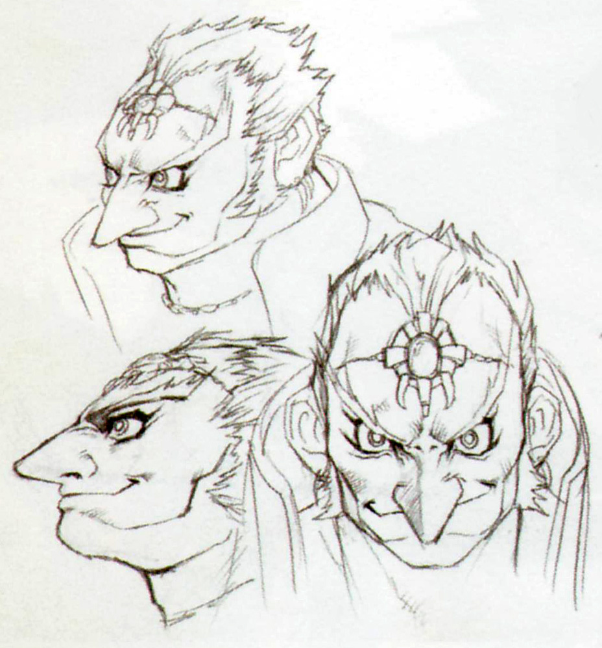

**Game World**

Unlike some previous Legend of Zelda titles, this game will be a linear progression to aid with cutscenes, and the story as a whole.

From landscape to landscape, Link will need to rid the town of whatever evil Ganon has placed as a conflict, and in every dungeon, Link will obtain a new item. This new item will open up previously inaccessible areas which will make the natural progression as obvious as possible without taking away Link’s feeling of freedom within the game world.

**Within the Game World**

The game world takes place in Hyrule, a setting similar to earth in many ways, with some obvious exceptions:

* Monsters, Ranging anywhere from bats to skeleton soldiers
* Different humanoid races:
  + Goron (rock people)
  + Zora (fish people)
  + Kokiri (forest sprites)
  + Hylian (humanoid with long point elflike ears)
  + Sentient animals
  + Other sentient humanoids
* The existence of magic

Within Hyrule, each different race resides in a different section of the map.

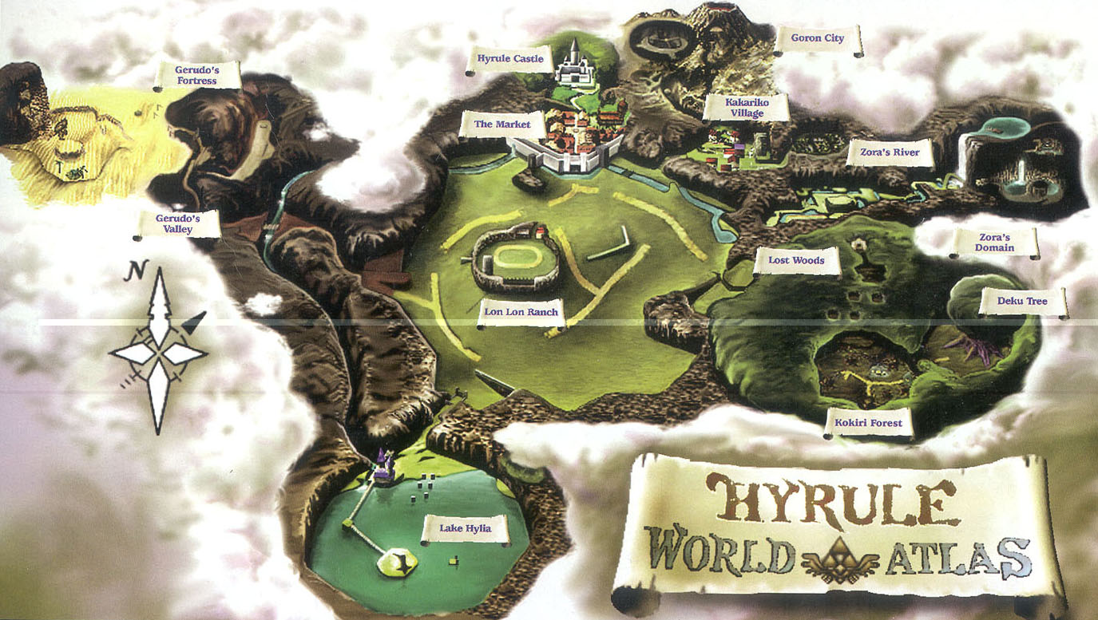

**Dungeons**

The primary challenges in this game will be the world’s many dungeons, which once solved and the final boss defeated, become milestones within the game’s story.

Each dungeon will follow a specific set of rules and items within.

Items to be found in any given dungeon:

* Map - Will give Link access to view the dungeon, and which rooms have and haven’t been visited.
* Compass - Will reveal the locations of hidden treasures within the dungeon
* Small Keys - Will unlock some doors within the dungeon it is found
* Key Items - Items such as the slingshot, bombs, etc. Will be found in the dungeon and will open up both new areas in the dungeon and outside world.
* Boss Key - Found last before anything else, this key will open the door to the Dungeon’s Boss.

While all of these items will be found in any dungeon, items found within a specific dungeon may only be used in that same dungeon. If Link leaves that dungeon, the items are removed from his inventory.

*Note: upon leaving the dungeon, these items will NOT be lost.

**Game Experience**

When the game is loaded up, the player will see various cutscenes of things to happen in the game. It will be followed by the classic “Legend of Zelda” title screen. From there, the player will be given an option to create or load a save file.

Emotions intended to invoke through this game are a sense of adventure, growth through maturity and responsibility, and conflict. Another massive narrative we are looking to convey is the power of friendship, and destiny.

The music will be a massive part of this game. It will help guide the player in the right direction, in addition to a multitude of functions directly involved with the concept of music, particularly the namesake for the subtitle, The Ocarina of Time.

The Ocarina will be a tool to open doors, unlock hidden passageways, cast magic, or teleport to previously visited destinations around the massive map.

In many ways the Ocarina of Time is a macguffin to push forth the narrative as well, as it is the only way Link can progress through the story in the particular manner that he will.

**Gameplay Mechanics**

**Gameplay Mechanics**

The plan to set this game apart massively from other action/adventure games is an innovative enemy targeting system. This is also a function Navi will perform for Link. She will fly near the enemy to further integrate the characters into the gameplay.

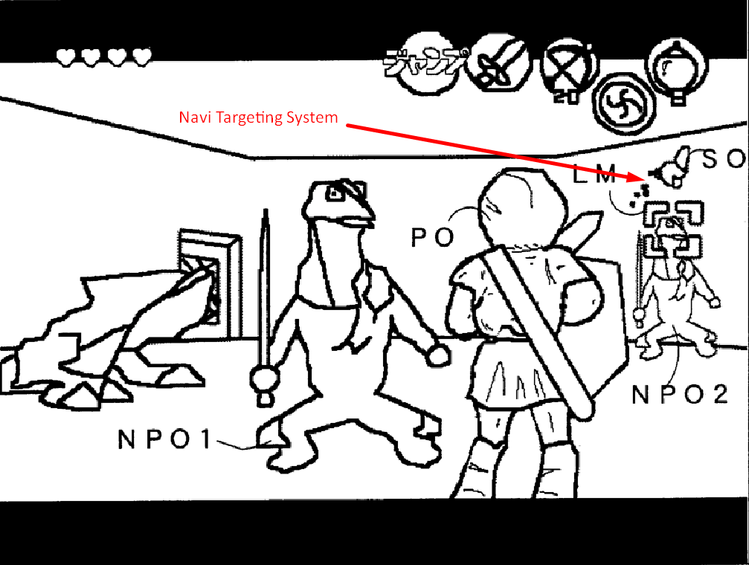

This targeting system will automatically control Link’s camera so that he is always facing the selected enemy. This allows for greater control over the action in combat, and an extremely easy way to quickly and effectively aim at an enemy with sword, magic or ranged weapons.

Past the introduction, Link will go through an entire section (Link’s hometown) where multiple NPCs will guide him through a non-invasive tutorial in order to explain the controls and systems to Link.

Once Link has completed enough tutorial tasks, the world will open with the introduction of the first dungeon. This dungeon will obviously be the easiest to complete.

*Battle Mechanics*

Battle mechanics include a numerous amount of catalysts.

Three dimensional movement combined with the targeting system (which enables strafing) is a battle mechanic on its own. This movement style is unlike anything that has ever been seen in gaming. The primary form of attack will be a swing of a sword, which will have a slash attack in the forms of

* Vertical Slash
* Horizontal Slash
* Stab
* Jump Attack
* Spin Attack

The jump and spin attacks are unique in comparison with the standard slash. Spin attack used against two Deku Babas picture below.

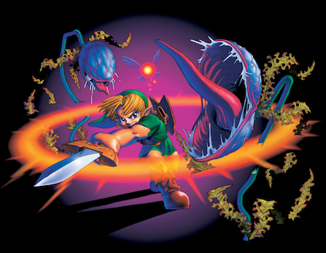

The jump attack will deal twice the amount of damage as a regular strike (will depend on the enemy Link is attacking), but will leave Link slightly open for counterattack by instating a short delay after the strike has taken place. The jump will begin based on where direction Link is facing at time of input, followed by a short jump forward.

The spin attack can be charged up to a number of degrees, in three stages. (damage compared to regular slash)

*Stage 1:* Regular Spin Attack (1 dmg) - short range, but circular motion

*Stage 2:* Weak Magic Spin Attack (1.5dmg) -medium range

*Stage 3:* Strong Magic Spin Attack (2dmg) -large range

The spin attack will involve Link holding the sword behind him to charge up. The longer Link holds the B button, the stronger the spin attack becomes. This can be held until Link is ready to unleash the attack!

In addition to melee attacks with the sword, Link has access to a variety of combat items such as:

*Slingshot -* Ranged Weapon, consumes seeds as ammunition

*Medallions -* Obtained from completing Dungeons. Elemental magic

*Bombs -* Explode!

*Boomerang -* Stun enemies from a range and returns to Link

**Hazards**

There will be a large number of hazards for link to overcome. Detailed below are some of the most common hazards:

* Razor Blade Traps - Move linearly back and forth, bouncing off of walls to create a floor trap that tests the player’s timing
* Bottomless Pits - Self explanatory. Link will reappear after falling into one of these with 1 less heart.
* Meteors - When climbing a certain area of a game, meteors will fall down, preventing Link from passing through alive without getting a certain item
* Lava - A classic hazard, Link will take extreme amounts of damage over time by walking on shallow lava. (Deep lava will be treated as a bottomless pit)

**Power Ups**

Power ups for Link will be limited to:

* Heart pieces and containers
* Magic Meter and Magic Meter extension - these will be obtained by finding a great fairy fountain.
* New items and clothing that will afford greater attack, defense or location-specific power

**Collectibles**

Collectibles include:

* Rupees (Currency)
* Golden Skulltulas (collecting certain amounts of these will afford link new items as rewards, or greater storage space)
* Depletable ammunition
* Magic potions and Fairies (Healing and Magic replenishment)

**Enemies**

There will be a boss monster, and a mini boss monster for each dungeon. Each of these monsters will have some form of bearing on the storyline, some more than others.

Some examples of common enemies veteran to the franchise include:

* Keese (Bats - can be “frozen” or “fire” elemental based enemies as well)
* Poe - Ghosts that turn invisible when targeted
* Stalfos - Skeleton monsters which appear at night time in Hyrule Field
* Deku Baba - Hostile plant monsters which leave items when killed
* Octorok - Water-based squid monsters that shoot projectiles at Link
* Skulltula - Spider monsters that block off certain pathways
* Like-Like - Sea Cucumberesque Monsters that swallow Link whole and steal his items
* Redead - Zombie-like monsters that paralyze Link temporarily then attack
* Lizalfos - Reptile Monsters that are formidable and wield blades

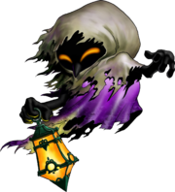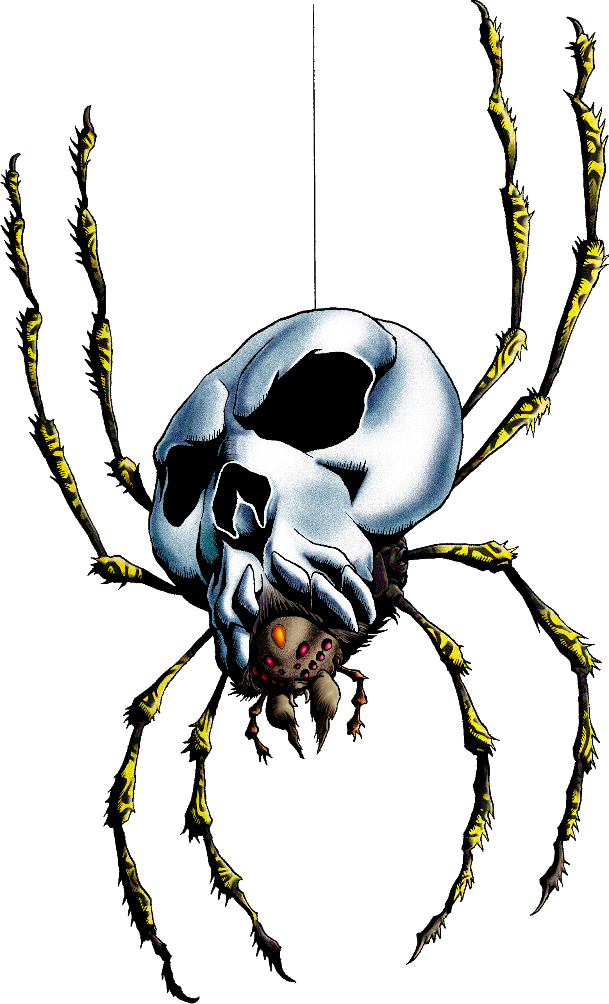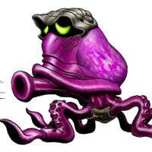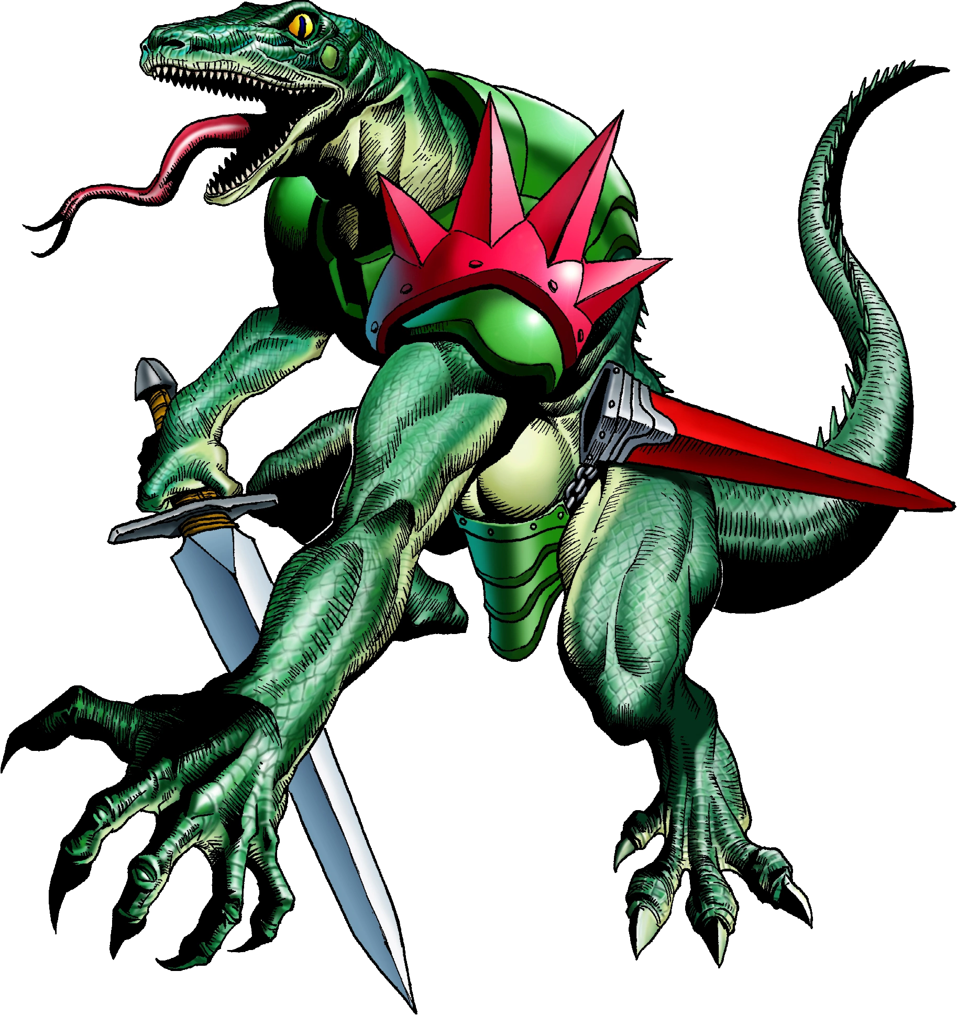

*Left to right: Poe, Skulltula, Octorok, Lizalfos*

There will be at least 3x the amount mentioned above, or at least there should be.

Link will have to find the weak spot of every enemy in order to defeat it. This will be additionally facilitated by the targeting system (with Navi) who will give hints to every monster’s weak spot by pressing a button.

**Summary**

All in all, The Legend of Zelda: The Ocarina of Time is a concept that will bridge the gaps between the storytelling of film, the depth of story of lost fables, and the excitement of interactivity of gaming.

This game will provide at least 30-40 hours of groundbreaking gameplay and a massive leap to truly test the capability of new generation gaming systems.